Report for edificio de trabajo con consumo normal

1. Time Series Characterization
Mean consumption: 25.681462140992167
Median consumption: 16.0
Std deviation: 28.750740413010895
Minimum consumption: 0
Maximum consumption: 191
95th percentile: 75.0
Total records: 383
Above Normal deviations: 13
Below Normal deviations: 2

2. Consumption Line Plot
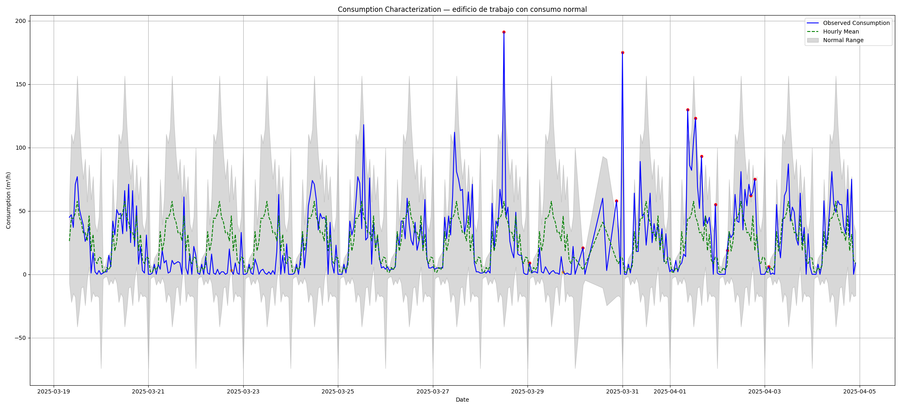

3. Deviation Heatmap
